Year 7 German End of Unit Test Jan 09

Exercise 1 (AT1)
Listen to conversations and write in English what each person likes to do.

1)_______________________________________
2)_______________________________________
3)_______________________________________
4)_______________________________________
5) ______________________________________
6) ______________________________________
7) ______________________________________
8) ______________________________________

Exercise 2 (AT3)
Read each person’s description of another person and write in English whether the following statements are true (T) or false (F) next to each one.

1) Bettina is tall.
2) Achim is loud and lazy.
3) Claudia is small.
4) Bettina is sporty.
5) Claudia is quiet and shy.
6) Achim is loud and tall.
7) Claudia is not musical.
8) Achim is quiet.
9) Bettina is moody.
10) Achim is intelligent and slim.

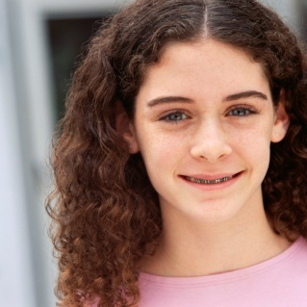
Meine Schwester heißt Claudia. Sie ist groß und schlank. Sie ist musikalisch und intelligent. Sie ist ruhig und ziemlich schüchtern.

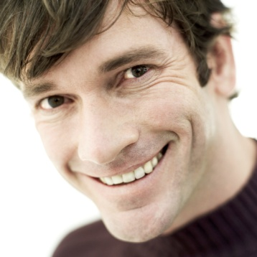
Bettina ist klein aber nicht schlank. Sie ist nicht dick und sie ist sehr sportlich. Sie ist meine Freundin aber launig.
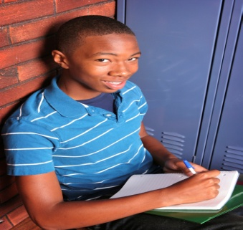
Mein Bruder heißt Achim und er ist klein. Er ist nicht intelligent. Er ist laut, faul und nicht lustig. Er ist sehr dick.

Exercise 3 (AT4)
Write a paragraph (at least 4 sentences) in German about yourself. Include information about how you look, what you are like and what you like to do. OPTIONAL: You could also include information about your family and what they are like and like to do.

____________________________________________________________________________________

____________________________________________________________________________________

____________________________________________________________________________________

____________________________________________________________________________________

____________________________________________________________________________________

____________________________________________________________________________________

____________________________________________________________________________________

Exercise 3 (AT4)
Write a paragraph (at least 4 sentences) in German about yourself. Include information about how you look, what you are like and what you like to do. OPTIONAL: You could also include information about your family and what they are like and like to do.

____________________________________________________________________________________

____________________________________________________________________________________

____________________________________________________________________________________

____________________________________________________________________________________

____________________________________________________________________________________

____________________________________________________________________________________

____________________________________________________________________________________

